julakanti harihanth (s4)

inagalla lohiya (s4)

mandala sai kushal (s4)

rahul nikki y (s5)

MULTIMEDIA WEB APPLICATION

COURSE INCHARGE | AMIT KUMAR

[Year]

**Contents:**

* **Problem Statement**
* **Application Overview**
* **Management and utilization perspectives**
* **Implementation and design of database management systems**
* **Entities used**
* **ER Diagram**
* **Relational Schema**
* **Table schema**
* **My SQL Executable code for tables**
* **Conversion table**
* **Functional dependencies**
* **Normalization**
* **Sample output of final normalized database table**

**Application Overview**

Multimedia web application is an online portal where a user have a unique id, username and password and for security reasons hash password also must be saved can upload media in which divides into images, videos, music in which each has a unique video_id, data_name for recognition which is given by the user and has address pointing to its location in his database and view which specifies whether certain media should be shown or hidden. Each type of media has its own section. Where he can upload images, videos, text and audio.

Store your media online and view media of our friends and this has separate sections of photos and videos and music and some media and can be made private and some other features.

A user can send a friend request for another user and can like, comment, share a particular media. User can also add the images from facebook, videos from YouTube, text from Gmail, music from sound cloud which have same options like the other media.

**Management and Utilization Perspectives:**

The traditional lifestyles of people have changed- Is your target audience still reading printed newspapers or magazines? Are they still watching that one popular show where the entire family gathers on a Sunday morning? So where are they then? On the world wide web- probably liking or sharing a post on facebook, enquiring regarding finding accommodation on twitter, commenting on a movie review posted on a blog, repining an amazing dress design they saw on their pin board or watching an advertisement released on youtube.

So By this project we want to widen the features like the user can directly upload his favourite videos, Music, and images from youtube, Facebook and Soundcloud respectively directly by pasting its address in the user input and can have whole media organized at one place so no need to visit all sites again and again and integrity, security and authentication is given importance for the user.

**Implementation and design of database management Systems:**

As there will be large number of tables and databases for all the users there might be concurrency and deadlock in some situations.So,the tables are normalized to at least to 3NF and some tables to BCNF according to the functional dependencies and decomposition of tables.

**Entities used:**

* user(user_id, username, active,password).
* user_info(mail_id,username,pic_link).
* friends_info(f_id,friend_name,joined).
* media(media_id,comments,likes,views).
* youtube(yt_up_id,yt_up_link,yt_up_name,views).
* facebook(fb_up_id,fb_up_link,fb_up_name,password).
* gmail(mail_id,mail_up_link,password).
* soundcloud(sc_up_id,sc_up_link,sc_name).
* videos(v_id,v_link,v_name,length,v_size,views).
* images(I_id,I_link,I_name,I_size).
* text(t_id,t_link,t_name,t_size).
* music(m_id,m_link,m_name,m_size,length,artist)

**ER DIAGRAM:**

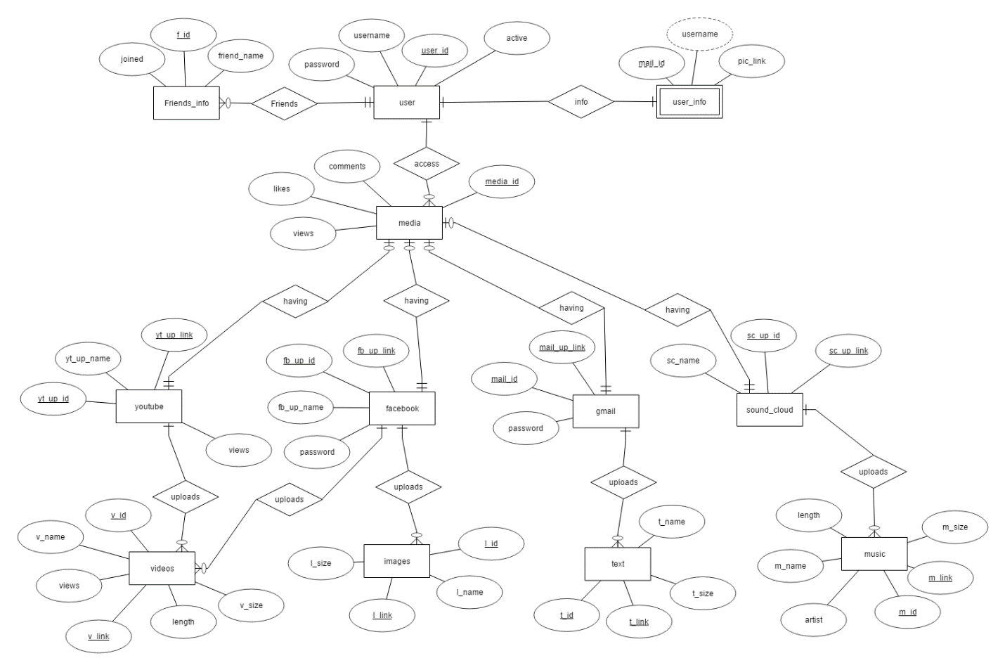

**Relational Schema:**

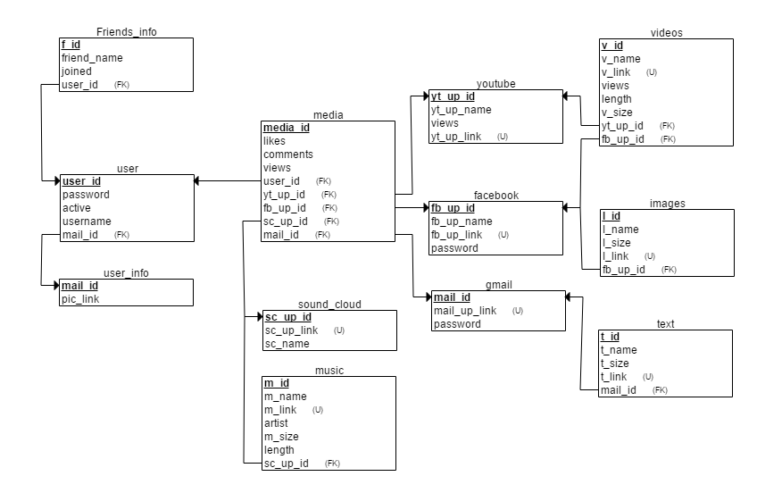

**Table schema:**

1. user (user_id, username, active,password).

|  |  |  |
| --- | --- | --- |
| **Attributes** | **Data Types** | **Constraints** |
| user id | Int | Primary Key |
| Username | Varchar (50) | Not Null |
| Password | Varchar (50) | Not Null |
| active | Varchar (50) | Not Null |

1. user_info(mail_id,username,pic_link).

|  |  |  |
| --- | --- | --- |
| **Attributes** | **Data Types** | **Constraints** |
| mail_id | Int | Primary Key |
| username | Varchar (50) | Not Null |
| pic_link | Varchar (50) | Not Null |

1. friends_info(f_id,friend_name,joined).

|  |  |  |
| --- | --- | --- |
| **Attributes** | **Data Types** | **Constraints** |
| f_id | Int | Primary Key |
| friend_name | Varchar (50) | Not Null |
| joined | Varchar (50) | Not Null |

1. media(media_id,comments,likes,views).

|  |  |  |
| --- | --- | --- |
| **Attributes** | **Data Types** | **Constraints** |
| media_id | Int | Primary Key |
| comments | Varchar (100) | Not Null |
| likes | Int | Not Null |
| views | Int | Not Null |

1. youtube(yt_up_id,yt_up_link,yt_up_name,views).

|  |  |  |
| --- | --- | --- |
| **Attributes** | **Data Types** | **Constraints** |
| yt_up_id | Int | Primary Key |
| yt_up_link | Int | Candidate Key |
| yt_up_name | Varchar (50) | Not Null |
| Views | Int | Not Null |

1. facebook(fb_up_id,fb_up_link,fb_up_name,password).

|  |  |  |
| --- | --- | --- |
| **Attributes** | **Data Types** | **Constraints** |
| fb_up_id | Int | Primary Key |
| fb_up_link | Int | Candidate Key |
| fb_up_name | Varchar (50) | Not Null |
| password | Varchar (50) | Not Null |

1. gmail(mail_id,mail_up_link,password).

|  |  |  |
| --- | --- | --- |
| **Attributes** | **Data Types** | **Constraints** |
| mail_id | Int | Candidate Key |
| mail_up_link | Int | Primary Key |
| password | Varchar (50) | Not Null |

1. soundcloud(sc_up_id,sc_up_link,sc_name).

|  |  |  |
| --- | --- | --- |
| **Attributes** | **Data Types** | **Constraints** |
| sc_up_id | Int | Primary Key |
| sc_up_link | Int | Candidate Key |
| sc_name | Varchar (50) | Not Null |
| Size | Int | Not Null |

1. videos(v_id,v_link,v_name,length,v_size,views).

|  |  |  |
| --- | --- | --- |
| **Attributes** | **Data Types** | **Constraints** |
| v_id | Int | Primary Key |
| v_link | Int | Foreign Key |
| v_name | Varchar (50) | Not Null |
| length | Int | Not Null |
| v_size | Int | Not Null |
| Views | Int | Not Null |

1. images(I_id,I_link,I_name,I_size).

|  |  |  |
| --- | --- | --- |
| **Attributes** | **Data Types** | **Constraints** |
| I_id | Int | Primary Key |
| I_link | Int | Foreign Key |
| I_name | Varchar (50) | Not Null |
| I_size | Int | Not Null |

1. text(t_id,t_link,t_name,t_size).

|  |  |  |
| --- | --- | --- |
| **Attributes** | **Data Types** | **Constraints** |
| t_id | Int | Primary Key |
| t_link | Int | Foreign Key |
| t_name | Varchar (50) | Not Null |
| t_size | Int | Not Null |

1. music(m_id,m_link,m_name,m_size,length,artist)

|  |  |  |
| --- | --- | --- |
| **Attributes** | **Data Types** | **Constraints** |
| m_id | Int | Primary Key |
| m_link | Int | Foreign Key |
| m_name | Varchar (50) | Not Null |
| m_size | Int | Not Null |
| length | Int | Not Null |
| artist | Varchar (50) | Not Null |

**MY SQL Executable code for tables:**

CREATE TABLE user

(

password INT NOT NULL,

active INT NOT NULL,

user_id INT NOT NULL,

username INT NOT NULL,

mail_id INT NOT NULL,

PRIMARY KEY (user_id),

FOREIGN KEY (mail_id) REFERENCES user_info(mail_id)

);

CREATE TABLE user_info

(

pic_link INT NOT NULL,

mail_id INT NOT NULL,

PRIMARY KEY (mail_id)

);

CREATE TABLE Friends_info

(

f_id INT NOT NULL,

friend_name INT NOT NULL,

joined INT NOT NULL,

user_id INT NOT NULL,

PRIMARY KEY (f_id),

FOREIGN KEY (user_id) REFERENCES user(user_id)

);

CREATE TABLE media

(

likes INT NOT NULL,

comments INT NOT NULL,

views INT NOT NULL,

media_id INT NOT NULL,

user_id INT NOT NULL,

yt_up_id INT NOT NULL,

fb_up_id INT NOT NULL,

sc_up_id INT NOT NULL,

mail_id INT NOT NULL,

PRIMARY KEY (media_id),

FOREIGN KEY (user_id) REFERENCES user(user_id),

FOREIGN KEY (yt_up_id) REFERENCES youtube(yt_up_id),

FOREIGN KEY (fb_up_id) REFERENCES facebook(fb_up_id),

FOREIGN KEY (sc_up_id) REFERENCES sound_cloud(sc_up_id),

FOREIGN KEY (mail_id) REFERENCES gmail(mail_id)

);

CREATE TABLE youtube

(

yt_up_name INT NOT NULL,

yt_up_id INT NOT NULL,

views INT NOT NULL,

yt_up_link INT NOT NULL,

PRIMARY KEY (yt_up_id),

UNIQUE (yt_up_link)

);

CREATE TABLE facebook

(

fb_up_name INT NOT NULL,

fb_up_id INT NOT NULL,

fb_up_link INT NOT NULL,

password INT NOT NULL,

PRIMARY KEY (fb_up_id),

UNIQUE (fb_up_link)

);

CREATE TABLE gmail

(

mail_id INT NOT NULL,

mail_up_link INT NOT NULL,

password INT NOT NULL,

PRIMARY KEY (mail_id),

UNIQUE (mail_up_link)

);

CREATE TABLE sound_cloud

(

sc_up_id INT NOT NULL,

sc_up_link INT NOT NULL,

sc_name INT NOT NULL,

PRIMARY KEY (sc_up_id),

UNIQUE (sc_up_link)

);

CREATE TABLE videos

(

v_id INT NOT NULL,

v_name INT NOT NULL,

v_link INT NOT NULL,

views INT NOT NULL,

length INT NOT NULL,

v_size INT NOT NULL,

yt_up_id INT NOT NULL,

fb_up_id INT NOT NULL,

PRIMARY KEY (v_id),

FOREIGN KEY (yt_up_id) REFERENCES youtube(yt_up_id),

FOREIGN KEY (fb_up_id) REFERENCES facebook(fb_up_id),

UNIQUE (v_link)

);

CREATE TABLE images

(

I_id INT NOT NULL,

I_name INT NOT NULL,

I_size INT NOT NULL,

I_link INT NOT NULL,

fb_up_id INT NOT NULL,

PRIMARY KEY (I_id),

FOREIGN KEY (fb_up_id) REFERENCES facebook(fb_up_id),

UNIQUE (I_link)

);

CREATE TABLE text

(

t_name INT NOT NULL,

t_size INT NOT NULL,

t_id INT NOT NULL,

t_link INT NOT NULL,

mail_id INT NOT NULL,

PRIMARY KEY (t_id),

FOREIGN KEY (mail_id) REFERENCES gmail(mail_id),

UNIQUE (t_link)

);

CREATE TABLE music

(

m_id INT NOT NULL,

m_name INT NOT NULL,

m_link INT NOT NULL,

artist INT NOT NULL,

m_size INT NOT NULL,

length INT NOT NULL,

sc_up_id INT NOT NULL,

PRIMARY KEY (m_id),

FOREIGN KEY (sc_up_id) REFERENCES sound_cloud(sc_up_id),

UNIQUE (m_link)

);

**Conversion table:**

|  |  |  |
| --- | --- | --- |
| **ENTITIES** | **RELATION** | **MySQL EXECUTABLE CODE** |
| user | User to user_info:  *One to One*  User to friends_info:  *Many to One*  User to media:  *Many to One* | CREATE TABLE user  (  password INT NOT NULL,  active INT NOT NULL,  user_id INT NOT NULL,  username INT NOT NULL,  mail_id INT NOT NULL,  PRIMARY KEY (user_id),  FOREIGN KEY (mail_id) REFERENCES user_info(mail_id)  ); |
| User_info | User_info to user:  *One to One* | CREATE TABLE user_info  (  pic_link INT NOT NULL,  mail_id INT NOT NULL,  PRIMARY KEY (mail_id)  ); |
| Friends_info | Friends_info to user:  One to Many | CREATE TABLE Friends_info  (  f_id INT NOT NULL,  friend_name INT NOT NULL,  joined INT NOT NULL,  user_id INT NOT NULL,  PRIMARY KEY (f_id),  FOREIGN KEY (user_id) REFERENCES user(user_id)  ); |
| Media | Media to youtube:  *One to One*  Media to facebook:  *One to One*  Media to gmail:  *One to One*  Media to sound cloud:  *One to One* | CREATE TABLE media  (  likes INT NOT NULL,  comments INT NOT NULL,  views INT NOT NULL,  media_id INT NOT NULL,  user_id INT NOT NULL,  yt_up_id INT NOT NULL,  fb_up_id INT NOT NULL,  sc_up_id INT NOT NULL,  mail_id INT NOT NULL,  PRIMARY KEY (media_id),  FOREIGN KEY (user_id) REFERENCES user(user_id),  FOREIGN KEY (yt_up_id) REFERENCES youtube(yt_up_id),  FOREIGN KEY (fb_up_id) REFERENCES facebook(fb_up_id),  FOREIGN KEY (sc_up_id) REFERENCES sound_cloud(sc_up_id),  FOREIGN KEY (mail_id) REFERENCES gmail(mail_id)  ); |
| Youtube | Youtube to media:  *One to One*  Youtube to videos:  *Many to One* | CREATE TABLE youtube  (  yt_up_name INT NOT NULL,  yt_up_id INT NOT NULL,  views INT NOT NULL,  yt_up_link INT NOT NULL,  PRIMARY KEY (yt_up_id),  UNIQUE (yt_up_link)  ); |
| Facebook | Facebook to media:  *One to One*  Facebook to videos:  *Many to One*  Facebook to images:  *Many to One* | CREATE TABLE facebook  (  fb_up_name INT NOT NULL,  fb_up_id INT NOT NULL,  fb_up_link INT NOT NULL,  password INT NOT NULL,  PRIMARY KEY (fb_up_id),  UNIQUE (fb_up_link)  ); |
| Gmail | Gmail to media:  *One to One*  Gmail to text:  *Many to One* | CREATE TABLE gmail  (  mail_id INT NOT NULL,  mail_up_link INT NOT NULL,  password INT NOT NULL,  PRIMARY KEY (mail_id),  UNIQUE (mail_up_link)  ); |
| Sound cloud | Sound cloud to media:  *One to One*  Sound cloud to music:  *Many to One* | CREATE TABLE sound_cloud  (  sc_up_id INT NOT NULL,  sc_up_link INT NOT NULL,  sc_name INT NOT NULL,  PRIMARY KEY (sc_up_id),  UNIQUE (sc_up_link)  ); |
| Videos | Videos to youtube:  *One to Many*  Videos to facebook:  *One to Many* | CREATE TABLE videos  (  v_id INT NOT NULL,  v_name INT NOT NULL,  v_link INT NOT NULL,  views INT NOT NULL,  length INT NOT NULL,  v_size INT NOT NULL,  yt_up_id INT NOT NULL,  fb_up_id INT NOT NULL,  PRIMARY KEY (v_id),  FOREIGN KEY (yt_up_id) REFERENCES youtube(yt_up_id),  FOREIGN KEY (fb_up_id) REFERENCES facebook(fb_up_id),  UNIQUE (v_link)  ); |
| Images | Images to facebook:  *One to Many* | CREATE TABLE images  (  I_id INT NOT NULL,  I_name INT NOT NULL,  I_size INT NOT NULL,  I_link INT NOT NULL,  fb_up_id INT NOT NULL,  PRIMARY KEY (I_id),  FOREIGN KEY (fb_up_id) REFERENCES facebook(fb_up_id),  UNIQUE (I_link)  ); |
| Text | Text to gmail:  *One to Many* | CREATE TABLE text  (  t_name INT NOT NULL,  t_size INT NOT NULL,  t_id INT NOT NULL,  t_link INT NOT NULL,  mail_id INT NOT NULL,  PRIMARY KEY (t_id),  FOREIGN KEY (mail_id) REFERENCES gmail(mail_id),  UNIQUE (t_link)  ); |
| Music | Music to sound cloud:  *One to Many* | CREATE TABLE music  (  m_id INT NOT NULL,  m_name INT NOT NULL,  m_link INT NOT NULL,  artist INT NOT NULL,  m_size INT NOT NULL,  length INT NOT NULL,  sc_up_id INT NOT NULL,  PRIMARY KEY (m_id),  FOREIGN KEY (sc_up_id) REFERENCES sound_cloud(sc_up_id),  UNIQUE (m_link)  ); |

**Functional dependencies:**

1. **User:**

user_id -> username,password,active.

Username,password ->user_id,active.

1. **friends_info:**

f_id-> friend_name,joined.

1. **Media**:

Media_id-> likes,comments,views.

1. **user_info:**

mail_id,username ->pic_link.

1. **Youtube:**

yt_up_link-> yt_up_id,yt_up_name,views.

yt_up_id-> yt_up_link,yt_up_name,views.

yt_up_name-> views.

1. **Facebook:**

fb_up_id -> fb_up_link, fb_up_name,password.

fb_up_link-> fb_up_id, fb_up_name,password.

fb_up_name,password -> fb_up_id, fb_up_link.

1. **Soundcloud:**

sc_up_link -> sc_name,sc_up_id.

sc_up_id -> sc_up_name,sc_up_link.

1. **Gmail:**

mail_id -> mail_up_link,password.

mail_up_link ->mail_id,password.

1. **Videos:**

v_id -> v-link,v_name,size,length,views.

v_link ->v_id,v_name,size,length,views.

v_name,size ->length,views.

1. **Images:**

I_link ->I_id,I_name,I_size.

I_id ->I_link,I_name,size.

1. **Text:**

t_id ->t_link,t_name,t_size.

t_link ->t_id,t_name,t-size.

1. **Music:**

m_id ->m_link,m_name,length,artist,m_size.

m_link ->m_id,m_name,length,artist,m_size.

m_name,m_size-> length,artist.

**Normalization:**

1. **User:**

(It satisfies 1NF,2NF,3NF,BCNF)

**1NF:**

All the attributes are atomic in nature.

**2NF**

find all candidate keys. The candiates keys are { user_id}, { password,username}, The set of key attributes are: { user_id,password,username }

for each non-trivial FD, check whether the LHS is a proper subset of some candidate key or the RHS are not all key attributes

checking FD: user_id --> username,active,password

checking FD: username,password --> user_id,active

**3NF**

find all cadnidate keys. The candiates keys are { user_id}, { password,username}, The set of key attributes are: { user_id,password,username }

for each FD, check whether the LHS is superkey or the RHS are all key attributes

checking functional dependency user_id --> username,active,password

checking functional dependency username,password --> user_id,active

**BCNF**

A table is in BCNF if and only if for every non-trivial FD, the LHS is a superkey.

1. **friends_info:**

(It satisfies 1NF,2NF,3NF,BCNF)

**1NF:**

All the attributes are atomic in nature.

**2NF**

find all candidate keys. The candiates keys are { f_id}, The set of key attributes are: { f_id }

for each non-trivial FD, check whether the LHS is a proper subset of some candidate key or the RHS are not all key attributes

checking FD: f_id --> friend_name,joined

checking FD: f_id,joined --> friend_name

checking FD: f_id,friend_name --> joined

**3NF**

find all cadnidate keys. The candiates keys are { f_id}, The set of key attributes are: { f_id }

for each FD, check whether the LHS is superkey or the RHS are all key attributes

checking functional dependency f_id --> friend_name,joined

checking functional dependency f_id,joined --> friend_name

checking functional dependency f_id,friend_name --> joined

**BCNF**

A table is in BCNF if and only if for every non-trivial FD, the LHS is a superkey.

1. **Media:**

(It satisfies 1NF,2NF,3NF,BCNF)

**1NF:**

All the attributes are atomic in nature.

**2NF**

find all candidate keys. The candiates keys are { media_id}, The set of key attributes are: { media_id }

for each non-trivial FD, check whether the LHS is a proper subset of some candidate key or the RHS are not all key attributes

checking FD: media_id --> comments,likes,views

**3NF**

find all cadnidate keys. The candiates keys are { media_id}, The set of key attributes are: { media_id }

for each FD, check whether the LHS is superkey or the RHS are all key attributes

checking functional dependency media_id --> comments,likes,views

**BCNF**

A table is in BCNF if and only if for every non-trivial FD, the LHS is a superkey.

1. **user_info:**

(It satisfies 1NF,2NF,3NF,BCNF)

**1NF:**

All the attributes are atomic in nature.

**2NF**

find all candidate keys. The candiates keys are { mail_id,username}, The set of key attributes are: { mail_id,username }

for each non-trivial FD, check whether the LHS is a proper subset of some candidate key or the RHS are not all key attributes

checking FD: mail_id,username --> pic_link

**3NF**

find all cadnidate keys. The candiates keys are { mail_id,username}, The set of key attributes are: { mail_id,username }

for each FD, check whether the LHS is superkey or the RHS are all key attributes

checking functional dependency mail_id,username --> pic_link

**BCNF**

A table is in BCNF if and only if for every non-trivial FD, the LHS is a superkey.

1. **Youtube:**

**1NF:**

All the attributes are atomic in nature.

**2NF:**

All the attributes are dependent on primary key only.

**3NF:**

Original schema { yt_up_id,yt_up_link,yt_up_name,views}

Primary key -> {yt_up_id, yt_up_link}

Yt_up_name -> views

Yt_up_id -> yt_up_name

Hence not in 3NF

So new table scheme

Scheme1 {yt_up_link, yt_up_name, views}

Scheme2 {yt_up_id, yt_up_name}

**BCNF**:

There is no inter relation among the candidate keys

1. **Facebook:**

(It satisfies 1NF,2NF,3NF,BCNF)

**1NF:**

All the attributes are atomic in nature.

**2NF**

find all candidate keys. The candiates keys are { fb_up_id}, { fb_up_link}, { fb_up_name,password}, The set of key attributes are: { fb_up_id,fb_up_link,fb_up_name,password }

for each non-trivial FD, check whether the LHS is a proper subset of some candidate key or the RHS are not all key attributes

checking FD: fb_up_id --> fb_up_link,fb_up_name,password

checking FD: fb_up_link --> fb_up_id,fb_up_name,password

checking FD: fb_up_name,password --> fb_up_id,fb_up_link

**3NF**

find all cadnidate keys. The candiates keys are { fb_up_id}, { fb_up_link}, { fb_up_name,password}, The set of key attributes are: { fb_up_id,fb_up_link,fb_up_name,password }

for each FD, check whether the LHS is superkey or the RHS are all key attributes

checking functional dependency fb_up_id --> fb_up_link,fb_up_name,password

checking functional dependency fb_up_link --> fb_up_id,fb_up_name,password

checking functional dependency fb_up_name,password --> fb_up_id,fb_up_link

**BCNF**

A table is in BCNF if and only if for every non-trivial FD, the LHS is a superkey.

1. **Soundcloud:**

(It satisfies 1NF,2NF,3NF,BCNF)

**1NF:**

All the attributes are atomic in nature.

**2NF**

find all candidate keys. The candiates keys are { sc_up_id}, { sc_up_link}, The set of key attributes are: { sc_up_id,sc_up_link }

for each non-trivial FD, check whether the LHS is a proper subset of some candidate key or the RHS are not all key attributes

checking FD: sc_up_id --> sc_up_link,sc_name

checking FD: sc_up_link --> sc_up_id,sc_name

**3NF**

find all cadnidate keys. The candiates keys are { sc_up_id}, { sc_up_link}, The set of key attributes are: { sc_up_id,sc_up_link }

for each FD, check whether the LHS is superkey or the RHS are all key attributes

checking functional dependency sc_up_id --> sc_up_link,sc_name

checking functional dependency sc_up_link --> sc_up_id,sc_name

**BCNF**

A table is in BCNF if and only if for every non-trivial FD, the LHS is a superkey.

1. **Gmail:**

(It satisfies 1NF,2NF,3NF,BCNF)

**1NF:**

All the attributes are atomic in nature.

**2NF**

find all candidate keys. The candiates keys are { mail_id}, { mail_up_link}, The set of key attributes are: { mail_id,mail_up_link }

for each non-trivial FD, check whether the LHS is a proper subset of some candidate key or the RHS are not all key attributes

checking FD: mail_id --> mail_up_link,password

checking FD: mail_up_link --> mail_id,password

**3NF**

find all cadnidate keys. The candiates keys are { mail_id}, { mail_up_link}, The set of key attributes are: { mail_id,mail_up_link }

for each FD, check whether the LHS is superkey or the RHS are all key attributes

checking functional dependency mail_id --> mail_up_link,password

checking functional dependency mail_up_link --> mail_id,password

**BCNF**

A table is in BCNF if and only if for every non-trivial FD, the LHS is a superkey.

1. **Videos:**

**1NF:**

All the attributes are atomic in nature.

**2NF:**

All the attributes are dependent on primary key only.

**3NF:**

Original schema { v_id, v_link, v_name, length, v_size, views }

Primary key -> {v_id, v_link}

v_id -> v_name, v_size

v_name, v_size -> length, views

Hence not in 3NF

So new table scheme

Scheme1 { v_id, v_name, v_size}

Scheme2 {v_name, v_size, length, views}

**BCNF**:

There is no inter relation among the candidate keys.

1. **Images:**

(It satisfies 1NF,2NF,3NF,BCNF)

**1NF:**

All the attributes are atomic in nature.

**2NF**

find all candidate keys. The candiates keys are { I_id}, { I_link}, The set of key attributes are: { I_id,I_link }

for each non-trivial FD, check whether the LHS is a proper subset of some candidate key or the RHS are not all key attributes

checking FD: I_link --> I_id,I_name,I_size

checking FD: I_id --> I_link,I_name,I_size

**3NF**

find all cadnidate keys. The candiates keys are { I_id}, { I_link}, The set of key attributes are: { I_id,I_link }

for each FD, check whether the LHS is superkey or the RHS are all key attributes

checking functional dependency I_link --> I_id,I_name,I_size

checking functional dependency I_id --> I_link,I_name,I_size

**BCNF**

A table is in BCNF if and only if for every non-trivial FD, the LHS is a superkey.

1. **Text:**

(It satisfies 1NF,2NF,3NF,BCNF)

**1NF:**

All the attributes are atomic in nature.

**2NF**

find all candidate keys. The candiates keys are { t_id}, { t_link}, The set of key attributes are: { t_id,t_link }

for each non-trivial FD, check whether the LHS is a proper subset of some candidate key or the RHS are not all key attributes

checking FD: t_id --> t_link,t_name,t_size

checking FD: t_link --> t_id,t_name,t_size

**3NF**

find all cadnidate keys. The candiates keys are { t_id}, { t_link}, The set of key attributes are: { t_id,t_link }

for each FD, check whether the LHS is superkey or the RHS are all key attributes

checking functional dependency t_id --> t_link,t_name,t_size

checking functional dependency t_link --> t_id,t_name,t_size

**BCNF**

A table is in BCNF if and only if for every non-trivial FD, the LHS is a superkey.

1. **Music:**

**1NF:**

All the attributes are atomic in nature.

**2NF:**

All the attributes are dependent on primary key only.

**3NF:**

Original schema { m_id, m_link, m_name, m_size, length, artist }

Primary key -> {m_id, m_link}

m_id -> m_name, m_size

m_name, m_size -> length, views

Hence not in 3NF

So new table scheme

Scheme1 { m_id, m_name, m_size}

Scheme2 {m_name, m_size, length, views}

**BCNF**:

There is no inter relation among the candidate keys.

**Sample output of final normalized database table:**

1. User

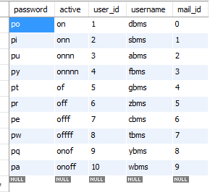

1. User_info

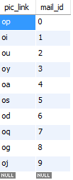

1. Friends_info

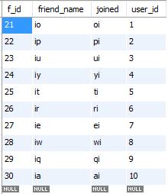

1. Media

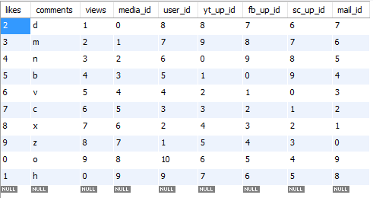

1. Youtube

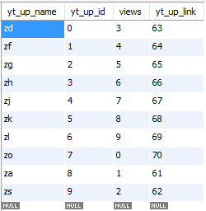

1. Facebook

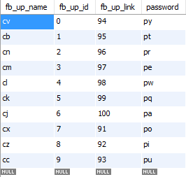

1. Gmail

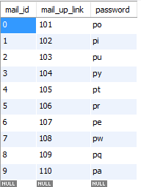

1. Sound_cloud

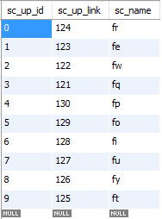

1. Videos

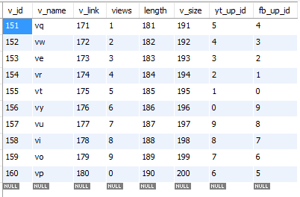

1. Images

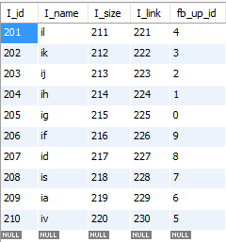

1. Text

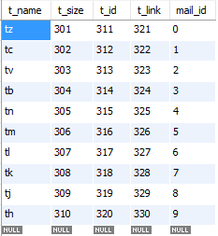

1. Music

